# Tremor analysis using smartphone compatible computer vision frameworks – Validity and challenges from a comparative study.

Robin Wolke MD1*, Julius Welzel Msc. Psych1*, Walter Maetzler MD1, Günther Deuschl MD, PhD1, Jos Becktepe MD1

*These authors contributed equally to this work.

1 Department of Neurology, UKSH, Kiel University

Corresponding Authors: Robin Wolke, Julius Welzel

Main : /5000 words

Abstract: 146/150 words

## Abstract

New video-based approaches hold a promising potential for application regrading movement disorders, but to fully utilize these, pipelines have to be validated against an established gold standard. This study investigates the validity of two smartphone compatible hand detection frameworks for tremor analysis in comparison to optical motion capture, accelerometry and clinical ratings. Our results show reliable measures of tremor peak frequency are feasible (Median absolute error: 0.15 Hz, IQR25-75: 0-0.325 Hz). We found significant correlation between the computer vision measure of amplitude and the TETRAS ratings but the estimates of tremor amplitude were less accurate compared to gold standard and showed a dependency on the actual magnitude of the tremor (Median error relative to OMC amplitude: 53.33%, IQR25-75: 34.40%-81.97%). We identified several limitations of the current frameworks in the context of tremor analysis which need to be considered for further development of a clinical assessment tool.

## Introduction

As computer vision (CV) techniques became more and more elaborate during the last decade, a growing number of clinicians are interested in its application. Especially, the field of movement disorders is predestined to apply CV and human pose estimation for the evaluation of different aspects of movements disorders (Park et al. 2021; Hu et al. 2022; Stefan Williams et al. 2020; Ardalan et al. 2021; Li et al. 2018). However, the assessment of tremor as a fast periodic movement of the limbs comes with specific challenges. Depending on etiology, the phenotypes of hand tremor span high to subtle amplitudes, slow to very fast frequencies, rest to action tremor and perfect sinusoidal to highly varying, irregular movements. Besides the clinician’s observation, accelerometric and or electromyographic tremor analysis is a valuable tool for differentiation of certain etiologies of tremor and to assess the peak frequency power as an objective marker for tremor amplitude. However, specific hardware and knowledge is necessary and the application of polygraphic tremor analysis by non-movement disorder specialist is not the usual (Deuschl et al. 2022). Therefore, the emerging potential to apply CV and smartphones for tremor analysis are at hand. While several elaborate approaches to analyze tremor in video recordings have already been reported, these are still of limited clinical applicability (Pintea et al. 2019; Fois et al. 2021; Stefan Williams et al. 2021; Wang et al. 2021; S. Williams et al. 2019; Güney et al. 2022). This study explores CV based approaches to tremor analysis and evaluates their performances regarding the accuracy of amplitude and frequency estimation in comparison to optical motion capture (OMC) and 3-dimensional accelerometry using an internal measurement unit (IMU). The CV-frameworks were the freely available “Mediapipe” (MP) framework including a hand-tracking model by “Google Research” (<https://google.github.io/mediapipe/solutions/hands.html>) and Apple’s Vision (VI) framework (<https://developer.apple.com/documentation/vision/detecting_hand_poses_with_vision>). Both frameworks are easy to deploy and integrate in smartphone apps using high-level Application Programming Interfaces (API). The potential usage on a smartphone is a hallmark that lowers the threshold for usage in the clinical routine.

Overall, a validation of a new method exclusively on real-world data is limited by the availability of suitable data. Regarding tremor analysis from videos important factors such as camera angle or framerate are challenging to assess systematically. 3D-simulation of movement offers a convenient approach to control for such factors. The integration of synthetic data is commonly applied both in evaluation and training of state-of-the-art computer vision algorithms (Man and Chahl 2022; Varol et al. 2017; Ebadi et al. 2022). Therefore - due to the limited availability of in-the-wild data of tremor patients - we evaluate our approach on a synthetic dataset of hand tremor movements first. This allows to fully control the experimental setup and in particular to identify the frameworks’ potential limitations **(Part 1)**. Secondly, we evaluate the performance on a real patient cohort by taking the prior knowledge derived from the virtual experiment for into account for the experimental setup and the data analysis **(Part 2)**.

## Results

## Part 1: Virtual Experiment

Both, MP and VI provide an internal measure of probable accuracy of their hand-detection models. We simulated a steadily trembling hand and rotated the camera in steps of 15 degrees around the virtual hand essentially covering a half-sphere of possible camera positions relative to the hand. This simulation resulted in a better accuracy when the hand was seen from above and preferably slightly from the side. The more the camera view changed towards a frontal (orthogonal) view the more the accuracy decreased. This phenomenon was more pronounced for VI (Figure 1 A, B). The amplitude estimations using MP norm (with and without z-axis) and VI revealed a roughly inverted pattern. The more orthogonal the camera viewpoint was relative to the hand the higher was the estimated amplitude (Figure 1 C, D). Logically, for views with very low accuracies an amplitude could not be estimated anymore due to too many frames without any detection (Figure 1 D).

For further evaluating the performance of CV on estimating the amplitude and change of amplitude we simulated a trembling hand with a linearly increasing amplitude. As figure 2 shows, the MP estimations of world landmarks could only roughly follow the change in amplitude. Regarding the normalized MP estimations, it becomes visible that the z-axis impairs the estimation compared to using only the y and x axis, in which case the change in amplitude is accurately modeled. Using the same simulation, we examined whether the detection of peak frequency is depending on amplitude. The peak frequency found to be robustly estimated throughout the simulation, for very small amplitudes the frequency can still be determined (Figure 2).

|  |
| --- |
| **Figure 1.** The upper heatmaps illustrate the estimated accuracy of the hand detection on the simulated videos for MP **(A)** and VI **(B)**. The angle of the camera in relation to the hand was systematically manipulated in order to give an impression of how the angle pairs represent the camera view. **1** illustrates the camera viewpoint at 0/0 (x-axis/y-axis), **2** the viewpoint at -45/-60 and **3** the viewpoint at 30/-60. From this result we deducted that a slightly elevated camera position is most likely to provide a stable hand detection for further analysis. However, the lower heatmapsillustrating the estimated logarithm of the tremor amplitude using the x/y/z coordinates of MP norm **(C)** and VI using x/y axis **(D)** suggests that the there is a tradeoff between accuracy and estimated amplitude depending on the camera viewpoint relative to the hand. For amplitude estimation using the MP norm data x- and y-axis only see suppl. figure 3. |
|  |
|  |
|  |



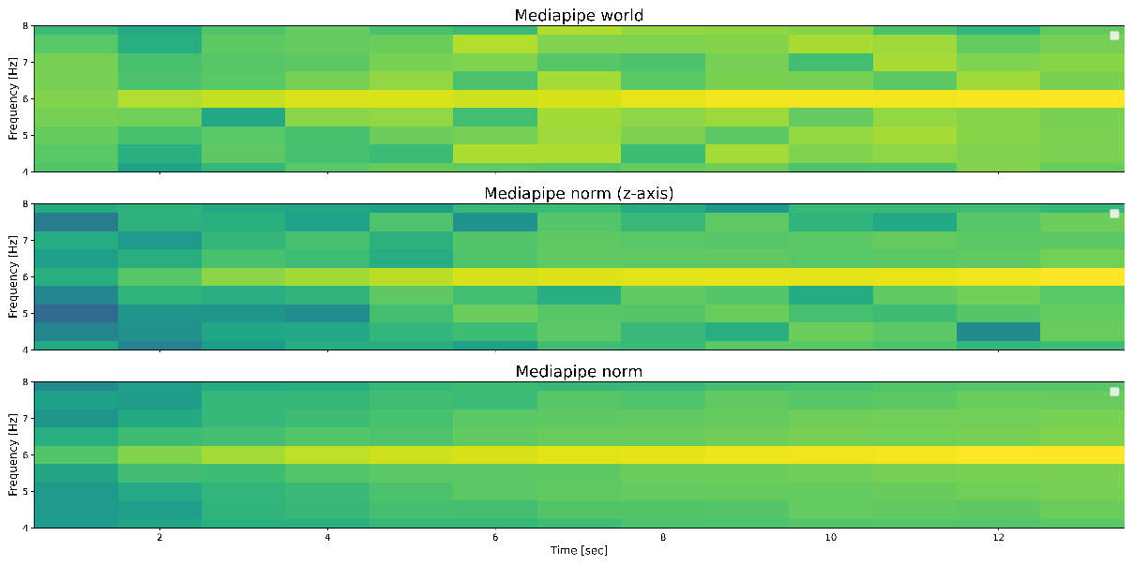

***Figure 2.*** *asdjsdlgjlkfsagljadgdalfgljdkjfgljdalkjglkjdajflkgjkldfajfgkldajgf*

Z normalisiert (oben)

#### Part 2: Validation on patient data

##### Amplitude estimation

Comparing the absolute estimation error of tremor amplitude in with the OMC amplitude measure as reference not significant differences were found. The median estimation error in millimeter was lowest for MP norm with 5.23 mm (MP world: 10.50 mm, MP world z-axis: 24.84 mm, MP norm z axis: 9.89 mm, VI: 6.55 mm, Figure 3, suppl. table 1).

However, the error is dependent of the actual tremor amplitude that is be estimated (Figure 4 A). Expressing the estimation error of the CV frameworks as a percentage of the OMC amplitude reveals that this relative error increases drastically for the MP world approaches and MP norm with z-axis once the amplitude falls below approximately 10 mm. VI shows the same trend but less pronounced (Figure 4 B). The relative error of MP norm remains stable with median of 53.30 % of the OMC amplitude (Figure 4 B, suppl. table 2).

The significant correlations of the log-transformed amplitude estimations to the TETRAS ratings indicate a certain degree of internal validity for the amplitude estimations of MP (Figure 5). This means the MP measures tendentially also increase as the tremor amplitudes increases. However, looking at the figure 5 in greater detail, it becomes evident that the estimated log transformations of amplitudes associated with different TETRAS score show often overlaps with preceding and consecutive scores. This even holds true for the log-transformation of the amplitude measured with OMC which correlates highly and significantly with the clinicians TETRAS rating.

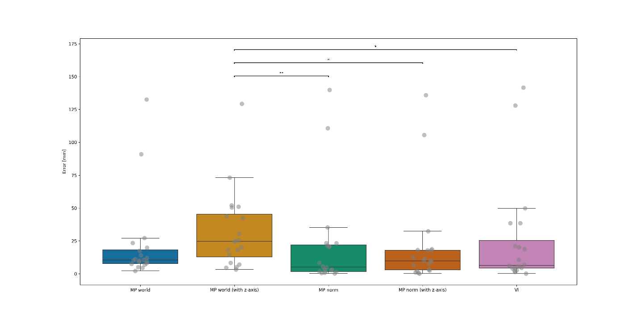

**Figure 3:** The boxplots show the absolute difference of the median tremor amplitude between OMC and the CV frameworks in millimeter. MP world z-axis showed significantly greater absolute estimation errors than MP norm, MP norm with z-axis and VI (Kruskal-Wallis test, Dunn post-hoc test). MP world = Mediapipe world landmarks (x/y), MP world z-axis = Mediapipe world landmarks (x/y/z), MP norm = Mediapipe normalized landmarks (x/y), MP norm (z-axis) = Mediapipe normalized landmarks (x/y/z), VI = Vision (x/y). MP world measures were scaled from meters to millimeters, for MP norm and VI scaling factors in relation to the OMC marker’s size, which was attached to the middle-finger’s tip, were applied.

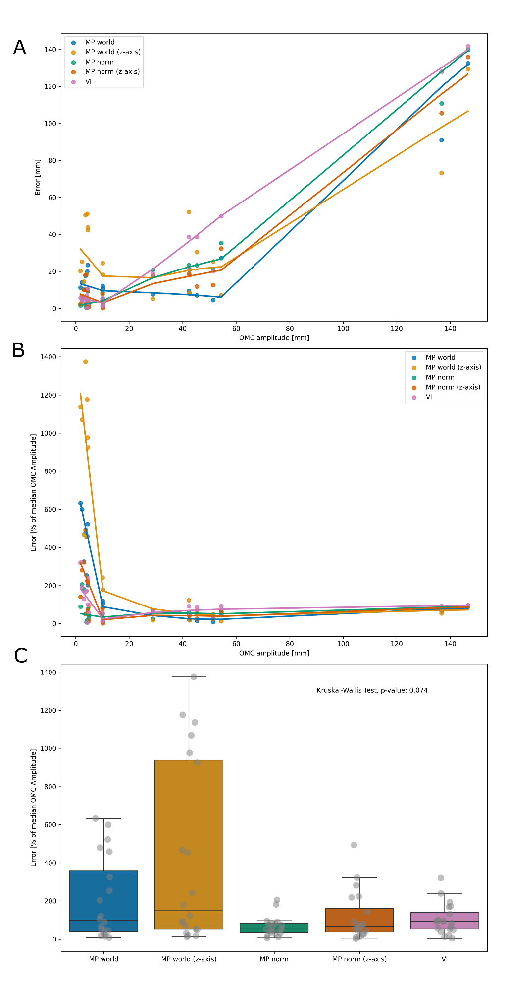

**Figure 4.** The upper scatter plot **(A)** shows the relation of the absolute estimation error of the different methods in millimeter against the OMC amplitude in millimeter. The plot in the middle shows **(B)** the same relation, but the amplitude estimation error of the different methods is expressed relative to OMC in % of the actual OMC amplitude and the OMC amplitude in millimeter. This illustrates that for tremor amplitudes <10 mm the relative amplitude estimation error of MP world and MP world z axis increases severely, followed by MP norm and VI. The bottom boxplots depict the relative amplitude estimation error across the different methods. There were not significant differences of the median estimation error, however the variability of MP world and MP world with z-axis was greater than the for the other methods (suppl. table 2). MP world = Mediapipe world landmarks (x/y), MP world z-axis = Mediapipe world landmarks (x/y/z), MP norm = Mediapipe normalized landmarks (x/y), MP norm (z-axis) = Mediapipe normalized landmarks (x/y/z), VI = Vision (x/y). MP world measures were scaled from meters to millimeters, for MP norm and VI scaling factors in relation to the OMC marker’s size, which was attached to the middle-finger’s tip, were applied.

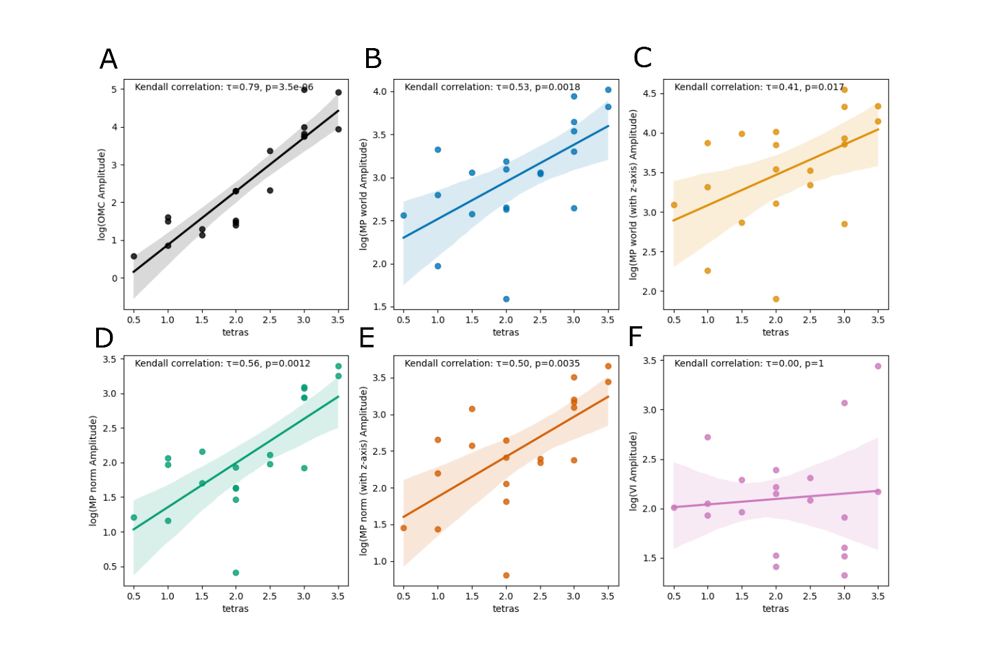

***Figure 5.*** *These plots show the correlations between the log-transformed amplitude estimations of all methods (****A****: OMC,* ***B****: MP world,* ***C****: MP world z-axis,* ***D****: MP norm,* ***E****: MP norm z-axis,* ***F****: VI) and the TETRAS rating. Except the log-transformed VI* ***(F)*** *amplitude estimations all methods showed a significant correlation to the clinical TETRAS ratings. OMC = Optical motion capture (x/y/z), MP world = Mediapipe world landmarks (x/y), MP world z-axis = Mediapipe world landmarks (x/y/z), MP norm = Mediapipe normalized landmarks (x/y), MP norm (z-axis) = Mediapipe normalized landmarks (x/y/z), VI = Vision (x/y). MP world measures were scaled from meters to millimeters, for MP norm and VI scaling factors in relation to the OMC marker’s size, which was attached to the middle-finger’s tip, were applied.*

##### Peak frequency estimation

Whilst only MP showed significant Kendall correlation with OMC and IMU regarding the estimated peak frequency using the RAW, PCA and EMD pipeline (Figure 6). The group-wise comparison between MP and VI of estimations errors relative to the OMC or IMU peak frequency did not result in significant differences for all three different pipelines. However, the frequency estimation errors of VI had a greater 25%-75% interquartile range (IQR25-75) compared to MP (see table 1). The frequency estimations of OMC and IMU correlated highly (Kendall’s tau: 0.85, p: <0.005, median difference 0.0 Hz, IQR25-75:0-0.2 Hz, maximum difference 1.0 Hz) (suppl. figure 5). The accuracy of frequency estimation depended significantly on the tremor amplitudes for both frameworks using the RAW pipeline and for MP using the EMD pipeline (Figure 7).

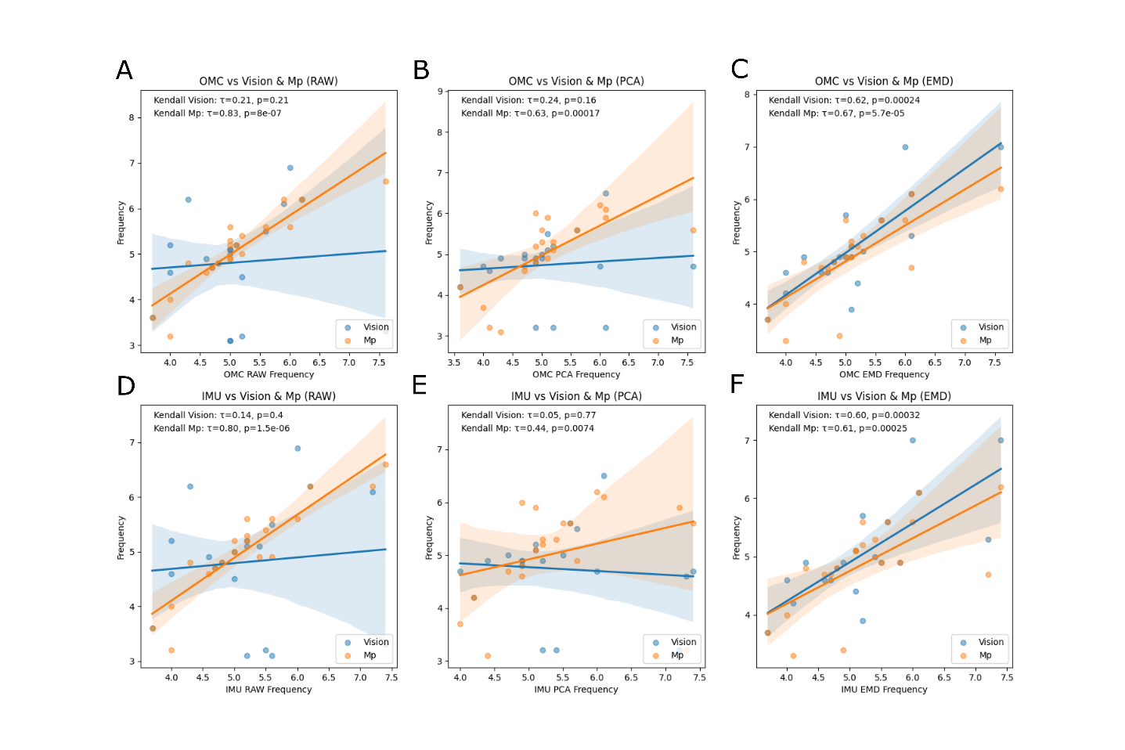

***Figure 6****. These Scatterplots show the estimated peak frequencies of MP and VI for all pipelines (RAW, PCA, EMD) compared to the ground truth of OMC and IMU. MP showed high and significant correlations with both OMC and IMU, Kendall’s tau decreased from 0.83 for RAW to 0.62 for PCA and 0.67 for EMD with OMC as ground truth. Same tendency was observed for IMU as ground truth (RAW: 0.80, PCA: 0.44, EMD: 0.61). The frequency estimation of VI did not correlate significantly with OMC and IMU for RAW and PCA. Using EMD VI did lead to significant correlations for both OMC (EMD: 0.62) and IMU (EMD: 0.60).*

|  |  |  |  |  |
| --- | --- | --- | --- | --- |
| Pipeline | Comparison | Median | 25th Percentile | 75th Percentile |
| RAW | VI vs. OMC | 0.25 | 0.1 | 1.375 |
| RAW | MP vs. OMC | 0.15 | 0 | 0.325 |
| RAW | VI vs. IMU | 0.4 | 0.075 | 1.375 |
| RAW | MP vs. IMU | 0.1 | 0 | 0.5 |
| PCA | VI vs. OMC | 0.4 | 0.075 | 0.85 |
| PCA | MP vs. OMC | 0.25 | 0.1 | 0.65 |
| PCA | VI vs. IMU | 0.35 | 0.075 | 1.475 |
| PCA | MP vs. IMU | 0.15 | 0 | 0.875 |
| EMD | VI vs. OMC | 0.2 | 0 | 0.625 |
| EMD | MP vs. OMC | 0.1 | 0 | 0.525 |
| EMD | VI vs. IMU | 0.4 | 0 | 0.625 |
| EMD | MP vs. IMU | 0.1 | 0 | 0.65 |

***Table 1:*** *Absolute differences in Hz of detected peak frequencies. There were no significance differences across framework (MP, VI; Mann-Whitney U test) and pipelines (RAW, PCA, EMD; Kruskal-Wallis-Test) for both OMC and IMU as ground truth.*

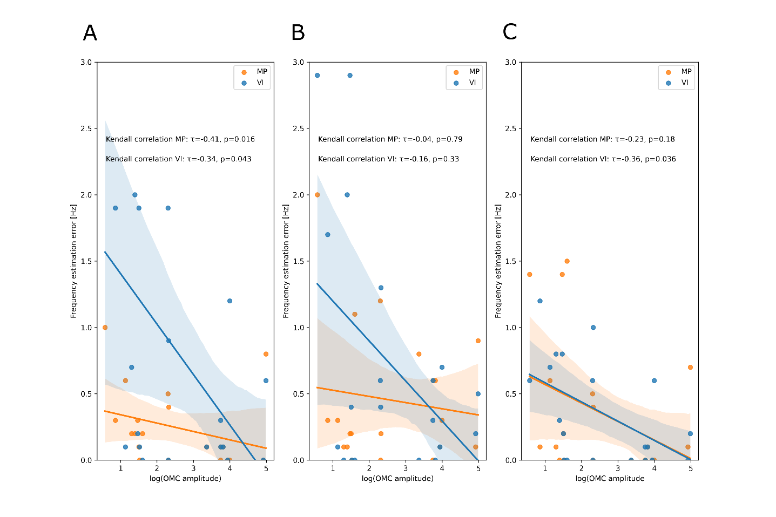

***Figure 7****. This scatterplot shows the logarithm of the OMC Amplitude in vs the frequency estimation error in Hz of MP and VI compared to the frequency detected by OMC for RAW* ***(A)****, PCA* ***(B)*** *and EMD* ***(C)*** *pipeline. The frequency estimation accuracy deteriorated slightly with lower tremor amplitudes.*

Discussion

In this study we extensively examined the capability of the MP and VI hand tracking framework to measure characteristics of hand tremor. In a first step, we evaluated whether the estimation accuracy depends on relative positioning of the hand and camera to each other leveraging a synthetic data approach. In a second step, a video dataset of 20 patients with hand tremor was collected with OMC and IMU recordings to compare the MP and VI estimations for tremors amplitudes and frequencies.

##### **Amplitude Domain**

However, the clinical impression of tremor severity does not follow a linear relationship but a logarithmic one that is consistent with the Weber-Fechner law (R. J. Elble 2018). In short, when a tremor movement with an amplitude of e.g. 10mm increases 10 mm this will be perceived as a significant difference, while the same increase to an amplitude of already 10 cm will not change the clinical importance. Therefore, even if MP norm relative estimation errors were not depending on the actual tremor’s amplitude, in a clinical application a median estimation error of 53% of the actual amplitude can change the grading of clinical severity. The significant correlations of the MP amplitude estimations with the TETRAS ratings should not be misinterpreted as in proof of a successful amplitude estimation. This is merely an indication of an internal validity of the CV methods. Qualitative changes of a tremor’s amplitude during a recording may be indeed detected, which is backed by the results of the simulation showing that the dimensions of the estimated amplitude of MP norm robustly follow the increase of the simulated amplitude (Figure 2).

However, intraindividual and comparisons between recording sessions should be interpreted with caution. In order to understand the inconsistent performance of amplitude estimation in our data, one has to consider that on the one hand the estimated tremor amplitude is depending on the camera viewpoint relative to the patient’s hand, but on the other hand also the accuracy of hand detection is related to the viewpoint (Figure 1). Being challenged by this trade-off we opted for a camera angle that ensured greater tracking accuracy in our real-world data. Potentially, more accurate amplitude estimations would be achieved with a more orthogonal camera view. The 3rd dimension of MP was not accurate enough to compensate influence of camera perspective and essentially introduced more noise in our measurements. The developers of MP state themselves it can be regarded as a 2.5D approach as the z-axis represents an estimation of depth (Lugaresi et al. 2019). While with more elaborate optical calibration techniques the amplitude estimation could have potentially been improved, we argue that a need of sumptuous optical calibration would contradict the ideal application of simply getting out a smartphone and conduct tremor analysis. Therefore, improved 3D Hand tracking e.g. achieved by the integration of Lidar sensors or augmented reality could help to evade this trade-off and to ensure feasibility in a clinical context.

##### **Frequency Domain**

The results of the simulations and the real-world data show that peak frequency estimation using CV is generally a promising approach. As our patient cohort showed a wide range of tremor amplitudes and different clinical phenotypes, the frequency estimation using CV can be evaluated as overall robust. MP performed more consistently then VI for frequency estimation in our experiments across all pipelines. Arguably this is due to less stable hand tracking results of VI (Figure 1D). While the RAW and PCA Pipeline did not correlate significantly with the frequency estimated by OMC or IMU, the EMD pipeline enhanced the VI frequency performance (Figure 6). Therefore, the application of EMD can potentially be of use in case of less accurate hand tracking e.g. due to an unfavorable camera angle or blurry footage to enhance the detection of tremor peak frequency. Whether the accuracy of frequency detection deteriorates by using PCA and EMD, provided a stable hand tracking performance like MP, needs to undergo further investigation. In our dataset the correlation coefficient decreased, the median frequency estimation error and the error’s IQR increased, but neither the differences between the pipelines (RAW, PCA, EMD) nor the frameworks (MP, VI) did reach the significance threshold. The frequency estimation error did show a significant relationship to the tremor’s amplitude for both VI and MP using the RAW pipeline and for VI using EMD pipeline (Table 1). However, the number of patients was small and further studies are needed to confirm whether the accuracy of frequency estimation is limited by a minimal amplitude. In this context one should also regard technical influences such as video resolution, distance to the hand, lighting of the scene and many more which may influence the minimal necessary tremor amplitude to perform an accurate frequency analysis. Beyond this, the range tremor of frequencies that can be detected seems to be only limited by the framerate of the recording. Therefore, we propose to use high framerates (e.g. 120 fps) which can be easily met with contemporary smartphones.

#### **Comparison to other approaches**

Pintea et al. compared two approaches of CV-based tremor analysis against synchronized accelerometry based analysis. 55 patients were assessed in a variety of different tasks resulting using the best approach in a mean average error approximately 1 Hz relative to the accelerometry based ground truth (Pintea et al. 2019). Williams et al evaluated an optical-flow based approach on videos of a total of 37 patients with differing entities of hand tremor. The results were validated against synchronized single-axis accelerometry. While achieving the proof of principle of an accurate estimation tremor frequencies from videos, amplitude estimation has not been explicitly examined (Stefan Williams et al. 2021). In accordance to our finding the frequency estimation error was not related to the amplitude, which was accessed with clinical ratings in this case. Park et al. analyzed videos of UPDRS III examinations of Parkinson patients with aid of the 2D pose estimation framework “OpenPose” (Cao et al. 2021). Then a Support vector machine was fed a with this information in order to automatically rate rest tremor and Bradykinesia. This resulted in a good overlap between machine and human UPDRS III ratings for rest tremor (Park et al. 2021). Similarly, Fois et al. applied the same framework on videos of rest tremor and finger-to-nose tremor examinations. In this cohort neurophysiologic measures (IMU, EMG) were available. The estimated logarithmic peak powers of this approach showed a convincing correlation to clinical ratings. However, regarding the peak frequencies the overlap between the CV based method and the neurophysiologic recordings proofed to be poor (Fois et al. 2021). Another recent work by Wang et al applied the MP hand detection framework on the dataset originally recorded by Pintea et al to detect hand tremor by feeding the retrieved information into different classification algorithms to determine whether tremor of the hand was present. Information on more specific characteristics of the tremors were not reported (Wang et al. 2021). During the ongoing research Güney et al. published a work that is as well based on the MP framework (Güney et al. 2022). However, their results are clinically incoherent as the mean tremor frequency of evaluated cohort of Parkinson patients was around 2 Hz and the videos were recorded while the arm were held stretched forward. Parkinsonian tremor is typically characterized by a resting tremor in the range of 4-7 Hz which can reemerge during holding conditions. Despite these limitations their analysis is flawed due to severe statistical misinterpretations.

Summarizing the previous works used optical flow, body pose-tracking with “open-pose” and MP hand-tracking to access tremor. While the estimation of tremor frequency based on CV is relatively accurate, correct amplitude estimations remains a challenge which is in line with our results.

#### **Conclusion**

Our results show that the Mediapipe framework returns, compared to the Vision framework, conveniently accurate estimates of peak-frequency and a rough estimate of tremors’ amplitudes even though neither of the CV frameworks was designed the purpose of tremor analysis. However, due to the pitfalls that we examined and discussed in this work further validation and enhancements to a CV based tremor analysis are crucial before broad clinical application. With some confidence regarding the exponential evolution of computer vision, one can expect that hand pose estimation will improve rapidly and therefore enhance the quality of contact free tremor analysis.

## Methods

|  |
| --- |
| **Figure 8**: Experimental Setup. The left side **(A)** shows the simulated hand in blender. Important tremor features could be controlled programmatically. On the right side **(B)** the real-world measurement setup is shown. Optical motion capture markers (yellow arrows) were attached to the wrist, the base and the tip of the middle finger and the tip of the thump. The green box depicts the position of the IMU attached to the palm. The red points and their connections are the 21 hand landmarks that are tracked by the “Mediapipe” (MP) and “Vision” (VI) framework (see also suppl. Figure 1). |

#### **Simulated data**

To achieve generate data, a 3D hand model was simulated in “Blender” to tremble under fully controlled circumstances (Blender 2022). We simulated hand movements in Blender and rendered videos from Blender to be passed into MP subsequently. The amplitude of hand movement, tremor frequency and angle of the camera in relation to the hand were manipulated. Both frameworks were able to detect the simulated hand (suppl. figure 2)

#### Acquisition of real-world data.

##### **Clinical data**

20 tremor patients were recruited consecutively from the tremor outpatient clinic at the department of neurology of the university hospital Kiel and gave their informed written consent. The ethics committee of Kiel university approved the study protocol (ID). The study was conducted in line with the declaration of Helsinki. Tremor was rated by an experienced movement disorders specialist using “The Essential Tremor Rating Assessment Scale” (TETRAS) (R. Elble et al. 2012). Real-world world videos of tremor patients were recorded using a smartphone camera in slow-motion capture mode (Apple iPhone 12 mini,120 Hz, HD resolution 1920 x 1080 pixel), an optical motion capture system with 12 cameras (Qualysis, 340Hz/100 Hz) and IMUs (Noraxon myoMotion, 200 Hz). The markers for motion capture were attached on anatomical landmarks (see suppl. figure 1+2). The IMU was taped to the palm of the hand to avoid interference with the Mediapipe algorithm. Patients were seated on a chair with armrests for 30 seconds recordings. They were instructed to pose the arms in the position the tremor occurred (rest or holding the arm stretched forward). The Camera was setup on a tripod in 1.5 meters distance to the chair. The camera view focused on the hands from a above frontal position. This position was chosen taking into account the results of the virtual part of this study. The derived data and videos were stored locally and further analyzed in an offline pipeline.

|  |  |  |
| --- | --- | --- |
| Age (years) |  | 69.2 (15.0) |
| Sex (m/f) |  | 15/5 |
| Tremor type (rest/hold) |  | 7/13 |
| TETRAS Tremor of upper limb (0-5) |  | 2.175 (0.87) |
| Diagnosis | ET  ET Plus  PD  Functional  Physiologic | 8  5  5  1  1 |

***Table 2:*** *Clinical characteristics of the examined tremor patients.*

#### **Analysis Pipeline**

Following data acquisition, the MP and VI hand tracking algorithms were applied to both the real world and the simulated videos. MP returns the estimated x-, y- and z-positions of 21 tracked points relative to the width and height of the video-frame. The z-axis is described as having roughly the same scale as the x-axis (Lugaresi et al. 2019). VI returns the x- and y-positions of 21 landmarks at the same locations as MP (see supplementary). For further evaluation only point 4,9 and 12 were investigated. For optical motion capture, we tracked the x-,y- and z-positions of the tip of the thumb, the metacarpophalangeal joint of the middle finger and the tip of the middle finger. These points correspond to the points 4, 9 and 12 of the MP hand-tracking. From the IMU the x-, y- and z- acceleration-data were stored. Afterwards a band-pass-filter from 1-10 Hz was applied. The lower boundary of the band-pass filter was taken to assure the absence of voluntary movement artifacts or jitter due to inaccuracies during tracking in the signal.

#### **Amplitude Estimation**

For amplitude estimation, the distance between each consecutive point of the x/y/(z) locations measured by MP, VI and OMC of the tip of the middle finger was calculated. For the calculation of approximate scaling factors, the pixel size of the OMC markers of 9.5mm size was measured in x and y dimension. Since the wrist was fixed on the chair-rest, we assumed that the major quantity of movement will be roughly in a x/y plane. The cameras perspective was not considered as all videos were recorded under same circumstances. MP returns both normalized values and estimated “world-coordinates-landmarks”. For the latter, no scaling factor was applied. The resulting distances of consecutive points over time were band-pass filtered between 2-10 Hz. And amplitudes were extracted as shown in Figure 3. Usually, clinician judge the average tremor amplitude. To minimize the effect of potential outliers due to tracking errors we chose to compare the median amplitudes of MP, VI and OMC, all with each other and with the TETRAS ratings. We distinguished between the following approaches for MP depending on which data was used for amplitude estimation: “MP world”: x/y world coordinates, “MP world z-axis”: x/y/z world coordinates, “MP norm”: x/y normalized coordinates, “MP norm z-axis”: x/y/z normalized coordinates. MP world measures were scaled from meters to millimeters, for MP norm measures and VI scaling factors in relation to the OMC marker’s size (9.5 mm diameter), which was attached to the middle-finger’s tip, were applied. For the evaluation of amplitude estimation performance, the OMC results were regarded as ground truth. The IMU data was not further evaluated in the context of amplitude estimation as positions are not measured directly, the data would need double integration which is prone to errors and drift.

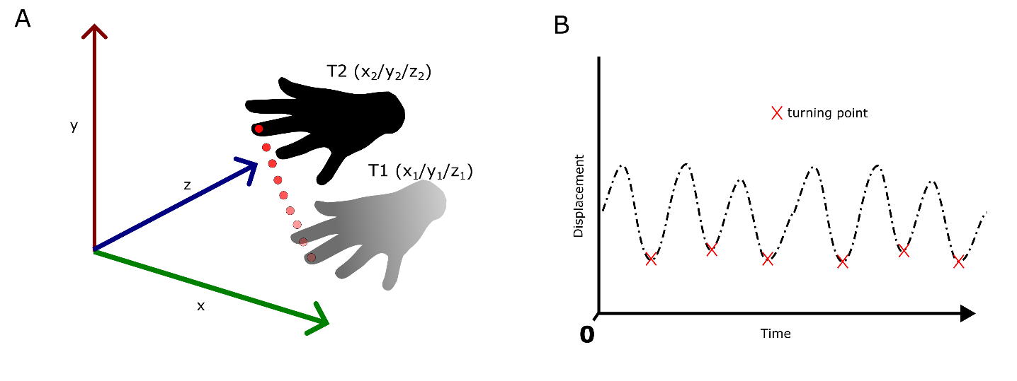

***Figure 9.*** *This figure illustrates the amplitude estimation algorithm. The Distance (D) between each consecutively tracked middle-fingertip was calculated using: $D=\sqrt{{\left(x_{2}-x_{1}\right)}^{2}+{\left(y_{2}-y_{1}\right)}^{2}+{\left(z_{2}-z_{1}\right)}^{2}}$. The resulting displacement signal was bandpass filtered between 2-10 Hz. The timepoint with the lowest displacement between two consecutive points was detected as a turning point during the tremorous movement. The sum of the displacement of the unfiltered signal between two consecutive turning points was calculated as the amplitude of one hand swing. The median of these amplitudes was calculated to estimate the overall tremor amplitude.*

#### **Frequency Peak detection**

The frequency spectra, of the x- and y-axis (plus z-axis for OMC and IMU) were estimated using Welch’s method. A frequency range of interest (FOI) was defined from 2-8 Hz in which peaks could be detected. Peak detection was performed on the derived spectra. The peaks with the highest power within the FOI was selected. For peak detection a threshold of 10% of the maximum power of the spectrum was set. Based on prior knowledge from the simulation results we derived the frequency spectra from the x- and y-axis of MP only.

#### **Statistical analysis**

For correlations between the measures derived from real-world data, Kendall’s tau was calculated. Group-wise comparisons were conducted using the appropriate non-parametric or parametric testing dependent on the data’s distribution.

**Acknowledgements**

#### **References**

Ardalan, Adel, Natasha Yamane, Ashwini K Rao, Jacqueline Montes, and Sylvie Goldman. 2021. ‘Analysis of Gait Synchrony and Balance in Neurodevelopmental Disorders Using Computer Vision Techniques’. *Health Informatics Journal* 27 (4): 14604582211055650. https://doi.org/10.1177/14604582211055650.

Blender, Foundation. 2022. ‘Blender.Org - Home of the Blender Project - Free and Open 3D Creation Software’. *Blender.Org* (blog). 22 June 2022. https://www.blender.org/.

Cao, Zhe, Gines Hidalgo, Tomas Simon, Shih-En Wei, and Yaser Sheikh. 2021. ‘OpenPose: Realtime Multi-Person 2D Pose Estimation Using Part Affinity Fields’. *IEEE Transactions on Pattern Analysis and Machine Intelligence* 43 (01): 172–86. https://doi.org/10.1109/TPAMI.2019.2929257.

Deuschl, Günther, Jos S. Becktepe, Michiel Dirkx, Dietrich Haubenberger, Anhar Hassan, Rick C. Helmich, Muthuraman Muthuraman, et al. 2022. ‘The Clinical and Electrophysiological Investigation of Tremor’. *Clinical Neurophysiology* 136 (April): 93–129. https://doi.org/10.1016/j.clinph.2022.01.004.

Ebadi, Salehe Erfanian, You-Cyuan Jhang, Alex Zook, Saurav Dhakad, Adam Crespi, Pete Parisi, Steven Borkman, Jonathan Hogins, and Sujoy Ganguly. 2022. ‘PeopleSansPeople: A Synthetic Data Generator for Human-Centric Computer Vision’. arXiv. https://doi.org/10.48550/arXiv.2112.09290.

Elble, Rodger, Cynthia Comella, Stanley Fahn, Mark Hallett, Joseph Jankovic, Jorge L. Juncos, Peter LeWitt, et al. 2012. ‘Reliability of a New Scale for Essential Tremor’. *Movement Disorders* 27 (12): 1567–69. https://doi.org/10.1002/mds.25162.

Elble, Rodger J. 2018. ‘Estimating Change in Tremor Amplitude Using Clinical Ratings: Recommendations for Clinical Trials’ 8 (0): 600. https://doi.org/10.5334/tohm.455.

Fois, Alessandro F., Neil Mahant, Steve Vucic, and Victor S.C. Fung. 2021. ‘Measuring Tremor—A Comparison of Automated Video Analysis, Neurophysiology, and Clinical Rating’. *Movement Disorders* 36 (12): 2962–63. https://doi.org/10.1002/mds.28776.

Güney, Gökhan, Talisa S. Jansen, Sebastian Dill, Jörg B. Schulz, Manuel Dafotakis, Christoph Hoog Antink, and Anne K. Braczynski. 2022. ‘Video-Based Hand Movement Analysis of Parkinson Patients before and after Medication Using High-Frame-Rate Videos and MediaPipe’. *Sensors* 22 (20): 7992. https://doi.org/10.3390/s22207992.

Hu, Hao, Dongsheng Xiao, Helge Rhodin, and Timothy H. Murphy. 2022. ‘Towards a Visualizable, De-Identified Synthetic Biomarker of Human Movement Disorders’. *Journal of Parkinson’s Disease* 12 (7): 2085–96. https://doi.org/10.3233/JPD-223351.

Li, Michael H., Tiago A. Mestre, Susan H. Fox, and Babak Taati. 2018. ‘Automated Assessment of Levodopa-Induced Dyskinesia: Evaluating the Responsiveness of Video-Based Features.’ *Parkinsonism & Related Disorders* 53 (August): 42–45. https://doi.org/10.1016/j.parkreldis.2018.04.036.

Lugaresi, Camillo, Jiuqiang Tang, Hadon Nash, Chris McClanahan, Esha Uboweja, Michael Hays, Fan Zhang, et al. 2019. ‘MediaPipe: A Framework for Perceiving and Processing Reality’. In *Third Workshop on Computer Vision for AR/VR at IEEE Computer Vision and Pattern Recognition (CVPR) 2019*. https://mixedreality.cs.cornell.edu/s/NewTitle_May1_MediaPipe_CVPR_CV4ARVR_Workshop_2019.pdf.

Man, Keith, and Javaan Chahl. 2022. ‘A Review of Synthetic Image Data and Its Use in Computer Vision’. *Journal of Imaging* 8 (11): 310. https://doi.org/10.3390/jimaging8110310.

Park, Kye Won, Eun-Jae Lee, Jun Seong Lee, Jinhoon Jeong, Nari Choi, Sungyang Jo, Mina Jung, et al. 2021. ‘Machine Learning–Based Automatic Rating for Cardinal Symptoms of Parkinson Disease’. *Neurology* 96 (13): e1761–69. https://doi.org/10.1212/WNL.0000000000011654.

Pintea, Silvia L., Jian Zheng, Xilin Li, Paulina J. M. Bank, Jacobus J. van Hilten, and Jan C. van Gemert. 2019. ‘Hand-Tremor Frequency Estimation in Videos’. In *Computer Vision – ECCV 2018 Workshops*, edited by Laura Leal-Taixé and Stefan Roth, 11134:213–28. Lecture Notes in Computer Science. Cham: Springer International Publishing. https://doi.org/10.1007/978-3-030-11024-6_14.

Varol, Gul, Javier Romero, Xavier Martin, Naureen Mahmood, Michael J. Black, Ivan Laptev, and Cordelia Schmid. 2017. ‘Learning from Synthetic Humans’. In *2017 IEEE Conference on Computer Vision and Pattern Recognition (CVPR)*, 4627–35. Honolulu, HI: IEEE. https://doi.org/10.1109/CVPR.2017.492.

Wang, Xinyi, Saurabh Garg, Son N. Tran, Quan Bai, and Jane Alty. 2021. ‘Hand Tremor Detection in Videos with Cluttered Background Using Neural Network Based Approaches’. *Health Information Science and Systems* 9 (1): 30. https://doi.org/10.1007/s13755-021-00159-3.

Williams, S., H. Fang, S. Shepherd, J. Alty, and C. D. Graham. 2019. ‘FM2-1 A Smartphone Camera Can Detect Functional Tremor’. *Journal of Neurology, Neurosurgery & Psychiatry* 90 (3): e23–24. https://doi.org/10.1136/jnnp-2019-ABN.74.

Williams, Stefan, Hui Fang, Samuel D. Relton, David C. Wong, Taimour Alam, and Jane E. Alty. 2021. ‘Accuracy of Smartphone Video for Contactless Measurement of Hand Tremor Frequency’. *Movement Disorders Clinical Practice* 8 (1): 69–75. https://doi.org/10.1002/mdc3.13119.

Williams, Stefan, Zhibin Zhao, Awais Hafeez, David C. Wong, Samuel D. Relton, Hui Fang, and Jane E. Alty. 2020. ‘The Discerning Eye of Computer Vision: Can It Measure Parkinson’s Finger Tap Bradykinesia?’ *Journal of the Neurological Sciences* 416 (September): 117003. https://doi.org/10.1016/j.jns.2020.117003.

# 2. Supplementary Material

**Methods**

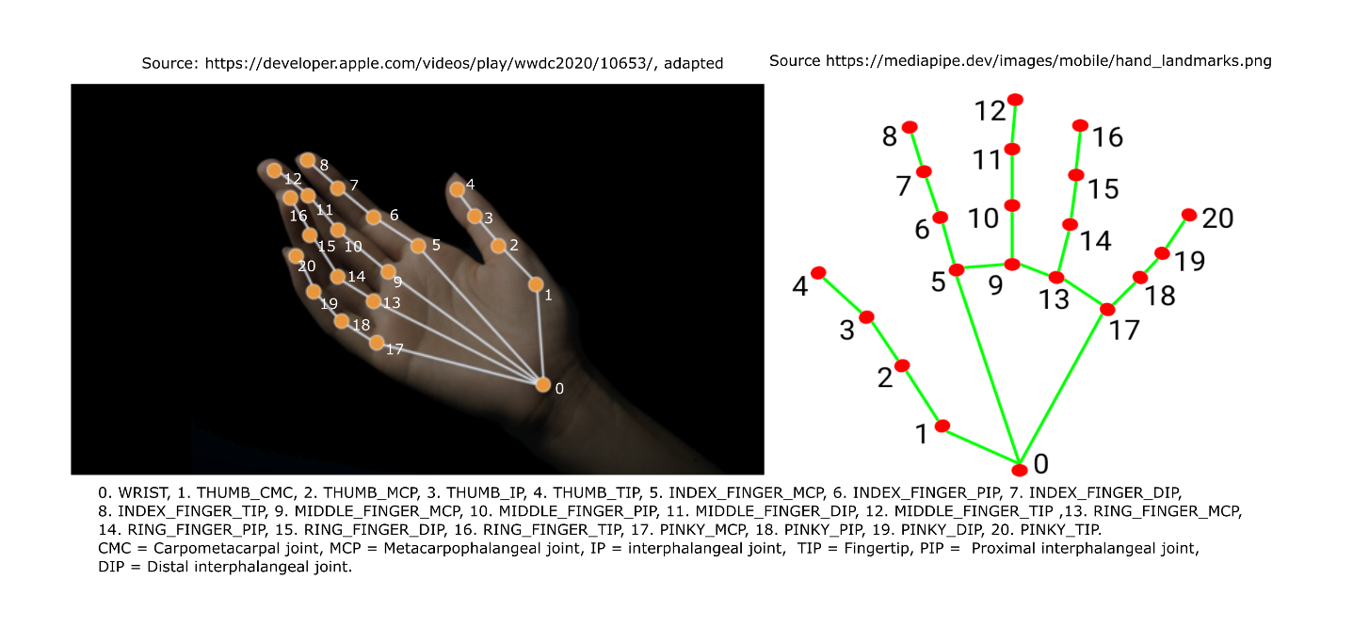

***Supplement Figure 1.*** *This figure shows the 21 tracked points by VI (left) and MP (right). For both frameworks the tracked landmarks where the same. VI returned x/y positions relative to the frames’ width and height, MP x/y/z positions normalized to the frames’ and height as well as x/y/z positions in estimated world coordinates.*

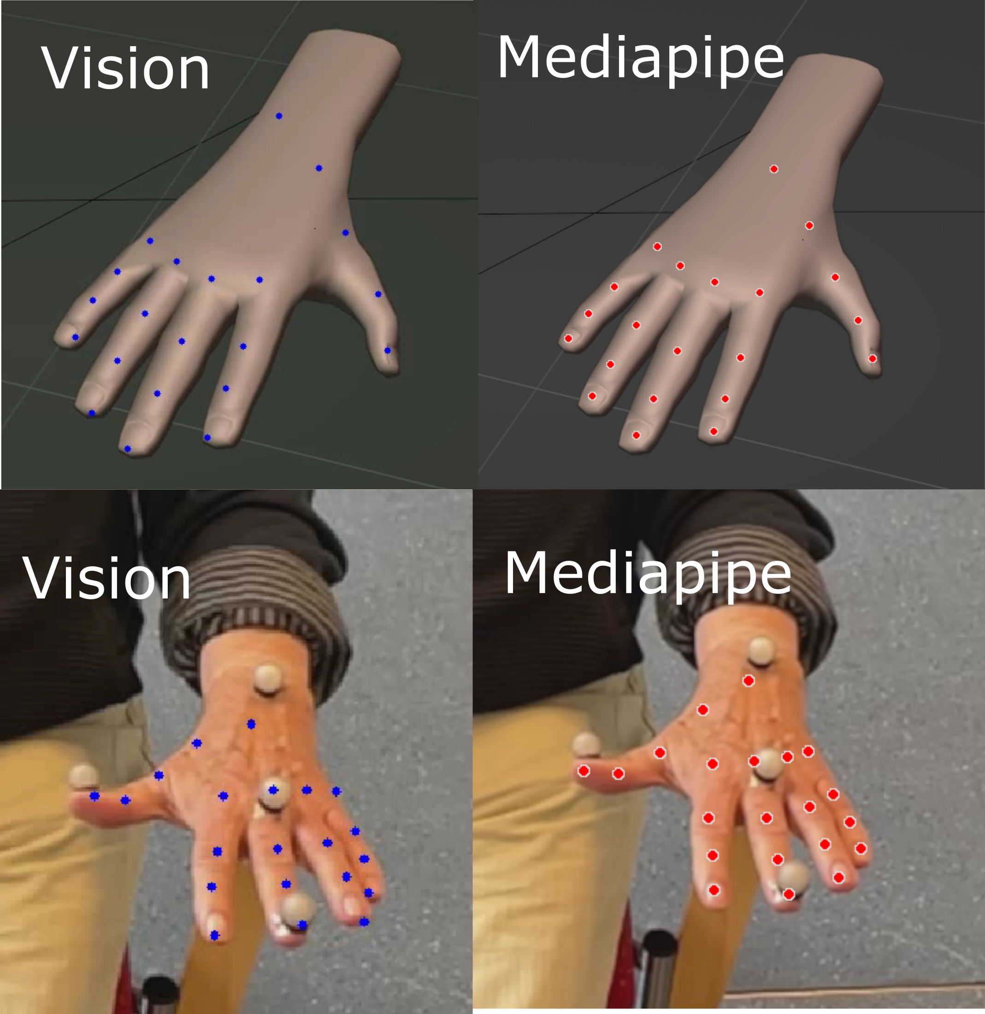

***Supplement Figure 2****. Example of**qualitative tracking results of VI and MP for simulated and real data. The OMC markers did not interfere severely with the tracking.*

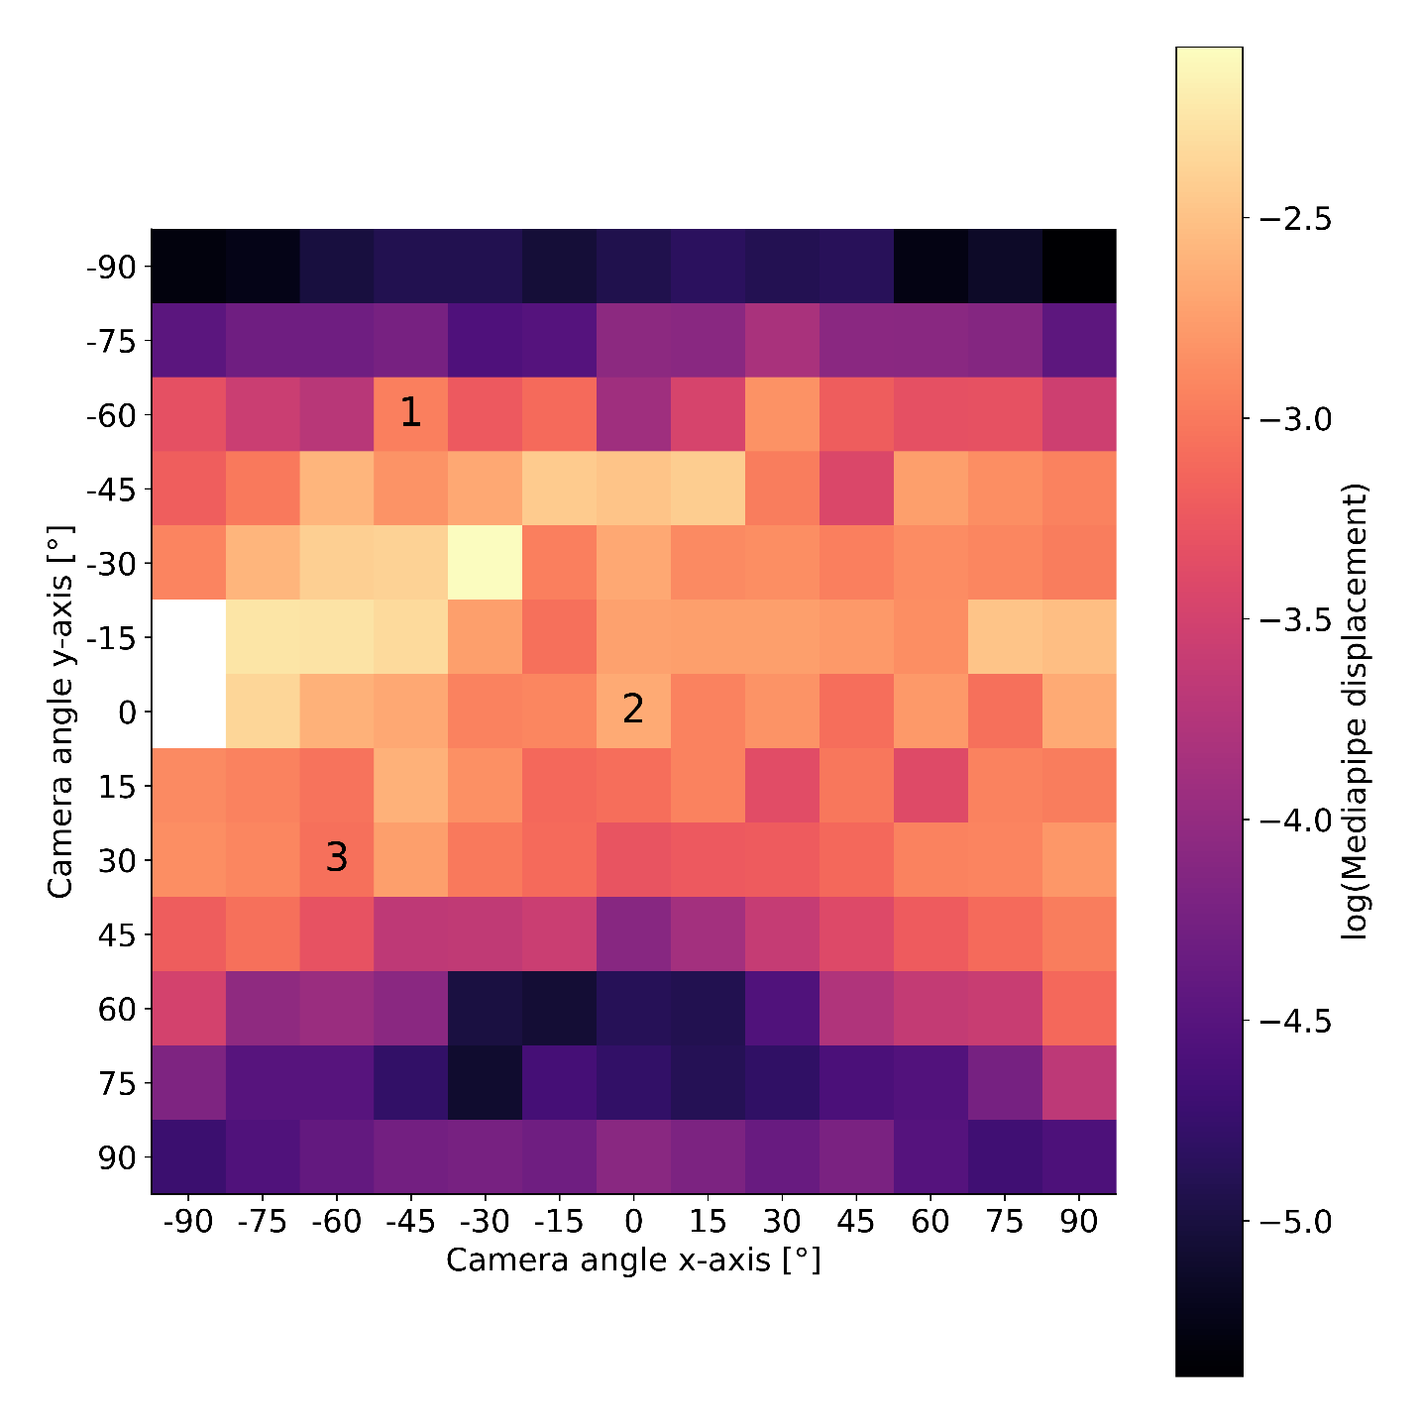

***Supplement Figure 3****. Estimated amplitude using the x/y/z axis of MP norm depending on camera viewpoint.*

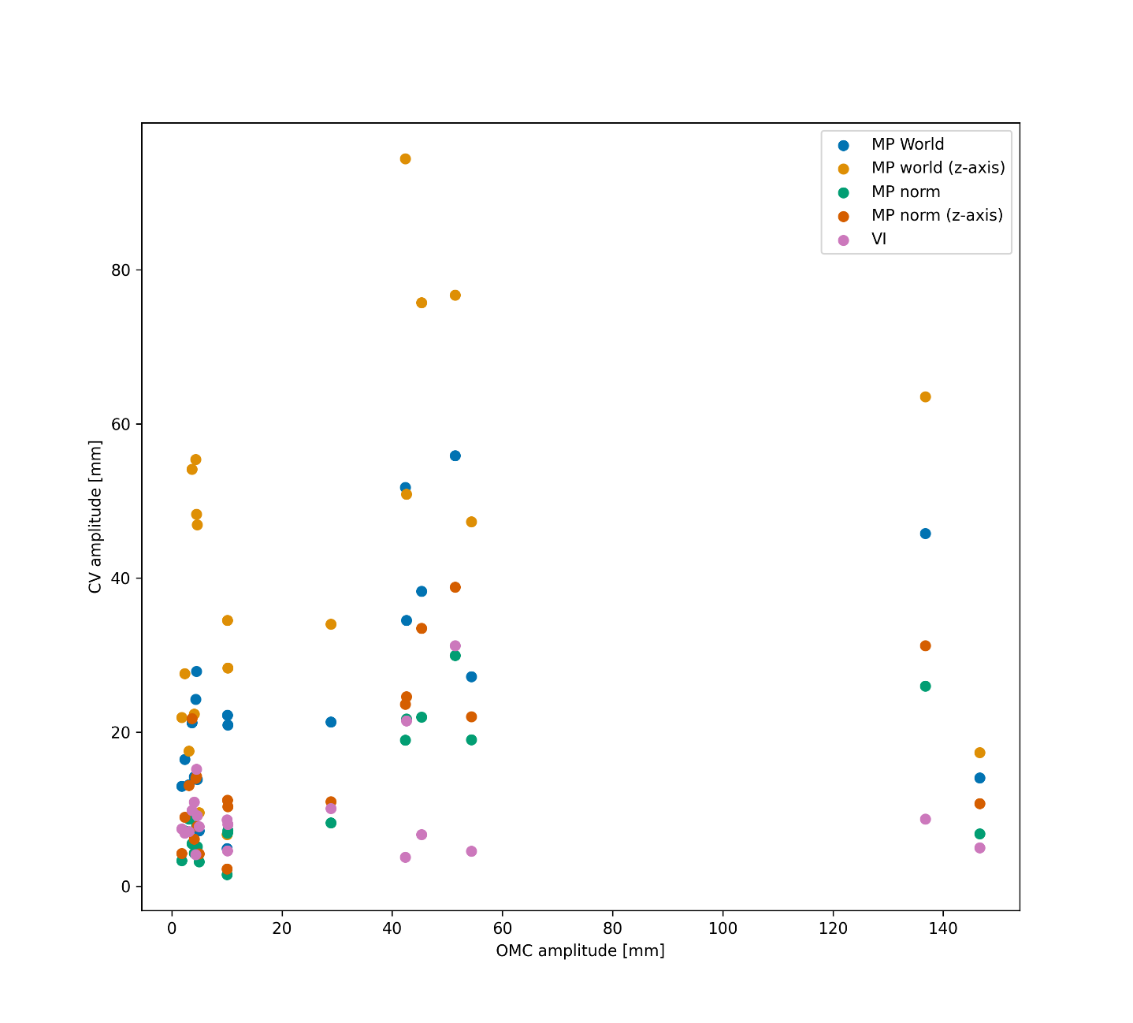

**Supplement Figure 4.** This scatterplot shows the estimated amplitude of the CV frameworks against the OMC amplitude.

|  |  |  |  |
| --- | --- | --- | --- |
| **Method** | Median | 25th Percentile | 75th Percentile |
| MP world | 10.4856 | 7.89209 | 18.1618 |
| MP world z-axis | 24.8423 | 12.9416 | 45.4511 |
| MP norm | 5.23321 | 1.82928 | 21.8998 |
| MP norm z-axis | 9.89151 | 3.04736 | 17.9575 |
| VI | 6.54825 | 4.41775 | 25.4508 |

**Supplement Table 1**: Absolute amplitude estimation error compared to OMC in millimeter.

|  |  |  |  |
| --- | --- | --- | --- |
| **Method** | **Median** | 25th Percentile | 75th Percentile |
| MP world | 98.0846 | 40.5801 | 358.838 |
| MP world z-axis | 150.668 | 52.4639 | 938.15 |
| MP norm | 53.3308 | 34.3935 | 81.9731 |
| MP norm z-axis | 66.231 | 38.0926 | 160.339 |
| VI | 91.3532 | 53.1769 | 139.684 |

**Supplement Table 2**: Relative amplitude estimation error compared to OMC in % of OMC amplitude.

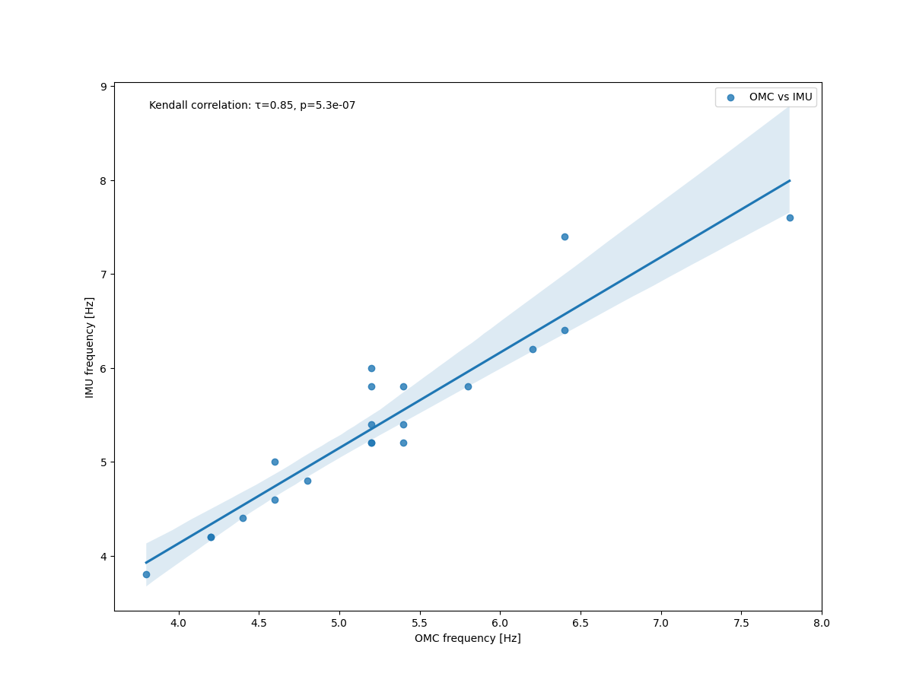

**Supplement Figure 5.** The frequency estimation by OMC and IMU using the RAW pipeline showed only minimal deviation between the identified peak frequency.